Design of a 170 GHz Waveguide-Based ENOCH Notch Filter for Burning Plasma Diagnostics Protection
Baron Li,¹ Shasha Qiu,¹ Logan Himes,¹ Xiaoliang Li,^{2,a)} Xinhang Xu,¹ and Yilun Zhu ¹
¹University of California Davis, Davis, California, 95616, USA
²Future Energy Acceleration & Translation (FEAT), Agency for Science, Technology and Research (A*STAR), 2 Fusionopolis Way, Innovis #08-03, Singapore 138634, Republic of Singapore.

(Presented XXXXX; received XXXXX; accepted XXXXX; published online XXXXX)
(Dates appearing here are provided by the Editorial Office)
Intense stray radiation from high-power 170 GHz gyrotrons used for Electron Cyclotron Heating (ECH) in magnetic confinement fusion devices poses a severe threat to sensitive microwave diagnostic receivers. To protect these critical front-end systems in next-generation burning plasma experiments, this paper presents ENOCH (Electromagnetic Notch Protection of Electron Cyclotron Heating), a novel 170 GHz waveguide-based notch filter. Engineered within a standard WR-06 waveguide geometry, the proposed eight-cavity resonant structure provides robust power protection without sacrificing diagnostic performance. Full-wave electromagnetic simulations demonstrate an exceptional rejection depth exceeding 90 dB at the 170 GHz interference frequency alongside a remarkably low insertion loss across the primary 134–166 GHz diagnostic passband. Furthermore, a coupled electromagnetic-thermal analysis confirms the filter's structural resilience under 100 W of continuous-wave input power. Compact, manufacturable, and easily integrated, the ENOCH design fulfills the stringent operational criteria required for reliable diagnostic protection in high-power, harsh environments typical of ITER- and ARC-class tokamaks.

I. INTRODUCTION
Owing to their non-invasive nature, high spatiotemporal resolution, and low maintenance, microwave diagnostics 1,Error! Reference source not found.,3 are widely employed for parameter measurement in magnetic confinement fusion devices and have contributed significantly to physical understanding. While advanced technologies like integrated Systems-on-Chip (SoC)^{4,5,6,7} , synthetic diagnostics ^{8,9,10} and machine learning ^{11,12} continue to enhance these systems, a new challenge has emerged. The use of high-power gyrotrons (e.g., 20 MW, 170 GHz)¹³ in current experimental and next-generation burning plasma devices for auxiliary heating and current drive generates intense stray/dangerous radiation. This poses a severe risk to microwave diagnostics^{14,15,16}, where electron cyclotron heating (ECH)¹⁷ can easily damage sensitive detectors, as shown in Fig. 1. To mitigate this, the development of a 170 GHz microwave notch filter is urgently required. The successful design and development of filters for 60 GHz¹⁸, 105 GHz ¹⁹, 110 GHz, 117.5 GHz, and 140 GHz^{20,21}applications provide a strong foundation for this challenging task.
The two predominant methodologies for millimeter-wave notch filters are the waveguide-based resonant cavity design and the planar Frequency Selective Surface (FSS)²² approach, each with distinct advantages and disadvantages dictated by their fundamental structures. Waveguide filters, as successfully deployed in fusion devices like W7-X for 140 GHz protection ²¹, offer superior performance in high-power environments; their key advantages include very deep rejection (> 60 dB), extremely narrow stopbands (enabling precise frequency targeting), high power handling capacity, and excellent structural integrity. However, these advantages come with the disadvantages of a larger, heavier mechanical assembly, a more precise fabrication process requiring precision machining, and a fundamental operational bandwidth limited by the waveguide's cutoff frequency.
^{a)}Author to whom correspondence should be addressed: Li_Xiaoliang@a-star.ed.sg

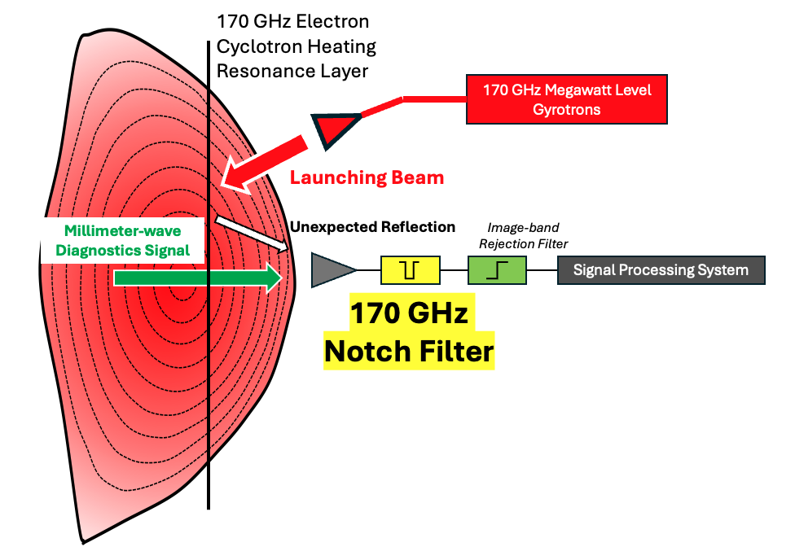
FIG. 1. ECH Reflection Hazard. An unexpected electron cyclotron heating (ECH) reflection beam entering the millimeter-wave receiver can mix with diagnostic signals. This risks saturating the signal or permanently damaging the receiver module through power overload. The 170 GHz ENOCH notch filter is essential for all millimeter-wave diagnostics on the burning plasma device.
In contrast, planar FSS filters are lightweight, low-profile, and amenable to cost-efficient fabrication techniques like photolithography, making them ideal for integrating into quasi-optical systems or imaging arrays. The primary disadvantages of the planar FSS approach, however, make it unsuitable for demanding fusion environments: they typically provide much weaker rejection, have a broader stopband that can attenuate desired diagnostic signals, and generally possess a lower threshold for power handling, risking damage or performance degradation under megawatt-level gyrotron radiation.
Consequently, the choice between them is application-specific: the waveguide solution is indispensable for high-power, high-precision protection in fusion diagnostics, while the FSS technology is better suited for lower-power, cost-sensitive applications where size and weight are important. In the development of the integrated microwave diagnostics system for burning plasma experiments, key design drivers include higher system integration and significantly enhanced power handling capacity. Given these stringent requirements, the waveguide-based notch filter approach is distinctly superior and better aligned with our application needs. Its inherent advantages, including exceptional power resilience, sharp rejection characteristics, and structural robustness, make it the most suitable solution for protecting sensitive diagnostics in this demanding environment.
The operational principles and design methodologies for resonant cavity notch filters are reviewed in Section 2, which also establishes the design specifications for the 170 GHz device. Section 3 presents the 3D electromagnetic model, covering the design of the fundamental resonator, the inter-cavity coupling mechanism, and the full multi-cavity structure. The simulated performance is analyzed and the optimization procedure is discussed in Section 4. The work concludes in Section 5 with a summary of the filter design and an evaluation of its deployment feasibility.
II. DESIGN REQUIREMENTS and SPECIFICATIONS
Based on the proven foundation of our previously developed 140 GHz notch filter for the W7-X device, the design process for the 170 GHz variant initiates with calculating the characteristic parameters of a single resonant cavity. The cylindrical cavity structure and the established slot configuration for interfacing with a standard rectangular waveguide are retained, as shown in Fig. 2. However, the shift to a higher frequency, with its correspondingly shorter wavelength, necessitates stricter machining tolerances and requires the design to be robust against higher relative fabrication errors. Additionally, in anticipation of a ~ 20 MW ECH power environment, effective thermal management is a critical performance consideration for the filter.
Guided by Equations (1) and (2), the wavelength (λ_{g}) inside the cylindrical cavity is determined, from which the cavity height (h) is derived. In the equations, λ is the operating wavelength at 170 GHz. The cutoff wavelength λ_{c} of the cylindrical waveguide for a TE mode is proportional to the diameter of the cylinder D. This height must be an odd multiple of the half-wavelength to fulfill the resonance condition. A key design decision for the 170 GHz filter is the adoption of a fixed physical structure, as opposed to a tunable cavity height. This choice enhances the filter's integrability, relaxes the demands on ultra-precision machining, and ultimately improves production yield. To achieve a sufficiently deep rejection depth, a multi-stage approach utilizing cascaded identical resonant structures will be implemented.
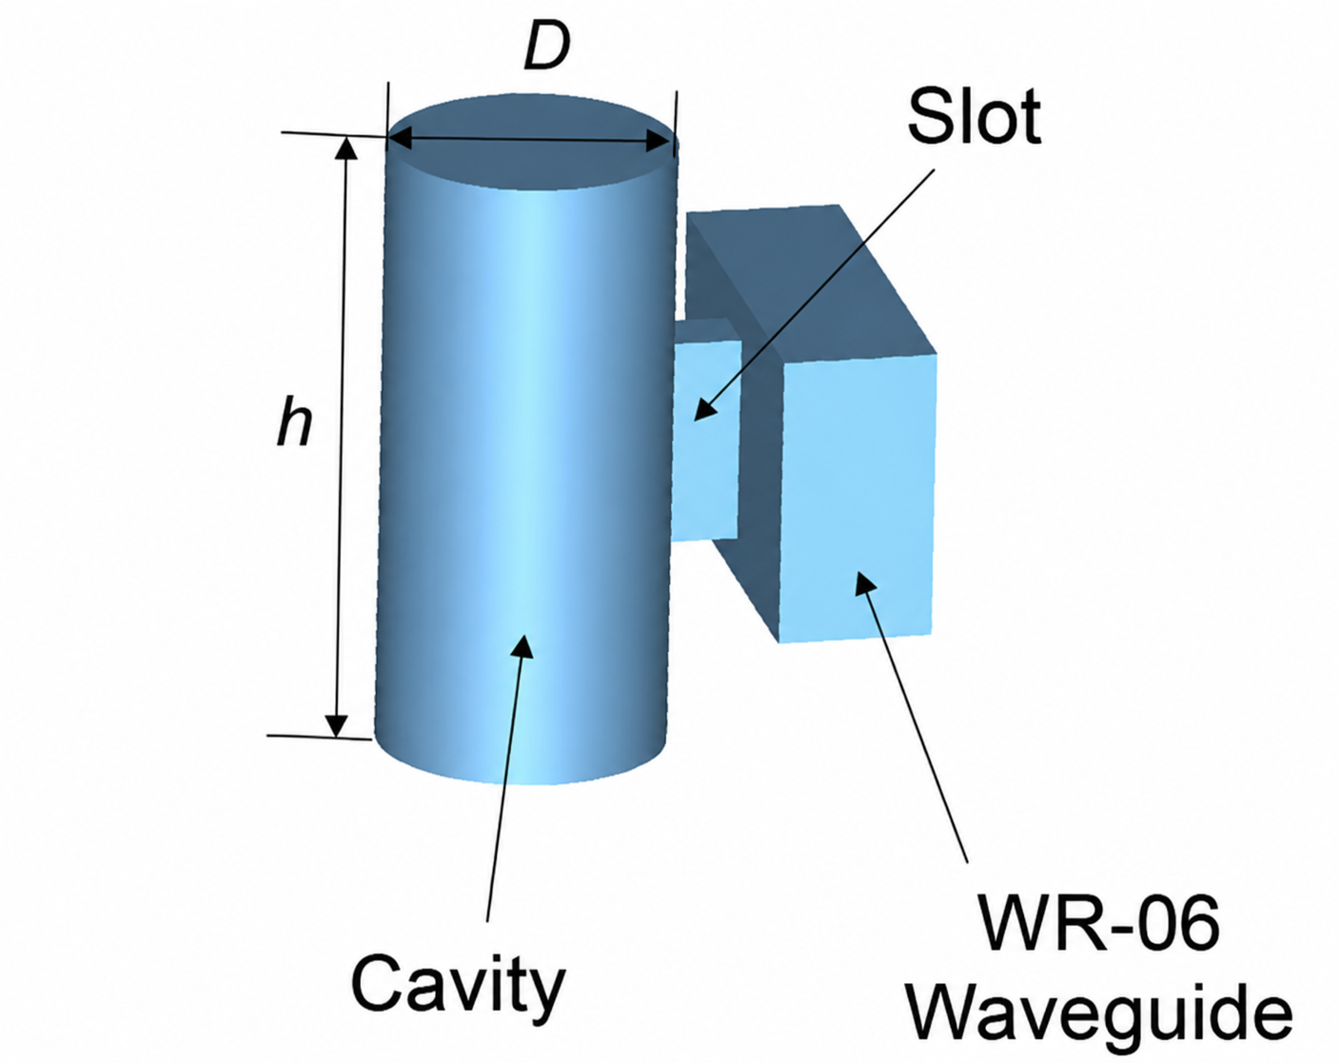
FIG. 2. Schematic illustration of the cylindrical resonant cavity integrated with a rectangular WR-06 waveguide for the ENOCH notch filter design.
$λ_{g}=\frac{λ}{\sqrt{1-{\left(\frac{λ}{λ_{c}}\right)}^{2}}}$ (1)
$h=p\frac{λ_{g}}{2} (p=1,2,3,…)$ (2)
To provide adequate attenuation in the rejection band, this notch filter is designed with multiple cavities. The number of cavities is directly related to the steepness and depth of the rejection band. More cavities result in better notch performance (i.e., attenuation at 170 GHz), but with more fabrication and tuning challenges. To provide excellent transmission between the cavities, the gap (l) between the cylindrical cavities should be taken as odd multiples (N) of the quarter-wavelength of the rectangular waveguide, as shown in the following equation:
$l=N\frac{λ_{g}}{4} (N=1,3,5,…)$ (3)
The 170 GHz notch filter is designed within a standard D-band WR-06 waveguide, measuring 1.651 mm in width and 0.8255 mm in height. The wavelength of the fundamental TE10 mode is calculated as 2.0856 mm for a 170 GHz wave. According to Eq. (3), the gap distance can be selected from various discrete lengths, including 0.5214 mm (N = 1), 1.5642 mm (N = 3), and 2.6070 mm (N = 5). In this design, the N = 3 configuration yielding a physical gap distance of 1.5642 mm is selected to optimize passband flatness while relaxing fabrication clearances between adjacent tuning walls.
The development of the 170 GHz waveguide notch filter is driven by the critical need to protect microwave diagnostics within a burning plasma environment, anticipated to feature 20 MW of auxiliary 170 GHz Electron Cyclotron Heating (ECH) power. To ensure reliable operation, the filter must exhibit a rejection depth greater than 90 dB at the specific 170 GHz gyrotron frequency while simultaneously maintaining a low insertion loss of less than 3 dB. The design targets an insertion loss below 1 dB across the essential 134 – 166 GHz passband utilized by diagnostics such as Frequency-Modulated Continuous Wave (FMCW) reflectometer ^{23,24} , Electron Cyclotron Emission (ECE) ^{25,26,27}, and Doppler Backscattering (DBS) ²⁸.
Leveraging proven experience from a 140 GHz predecessor, this design must also demonstrate robust power resilience by withstanding direct irradiation from 100 W of stray ECH power. A key thermal management requirement is that the filter's temperature remains below 100°C under this load with only natural convection cooling, a prerequisite for the safe integration of a thermally isolating waveguide section to protect downstream detectors from heat damage.
III. FITER DESIGN and PRELIMINARY RESULT
ENOCH (Electromagnetic Notch Filters for Electron Cyclotron Heating) is designed for integration at the front-end of a D-band receiver module for microwave radiometry, serving to protect the nanowatt-sensitivity receiver from 170 GHz ECH leakage entering through the vessel or other parasitic coupling paths. To achieve an optimal balance between rejection performance and fabrication feasibility, an eight-cavity configuration was selected. As illustrated in Fig. 3, the cavities are spaced with a gap of 2.450 mm between adjacent channels. This spacing, which is optimized for enhanced coupling between multiple cavities, was chosen to be shorter than the 5-times quarter-wavelength distance (L = 2.610 mm) to provide superior notch depth performance.
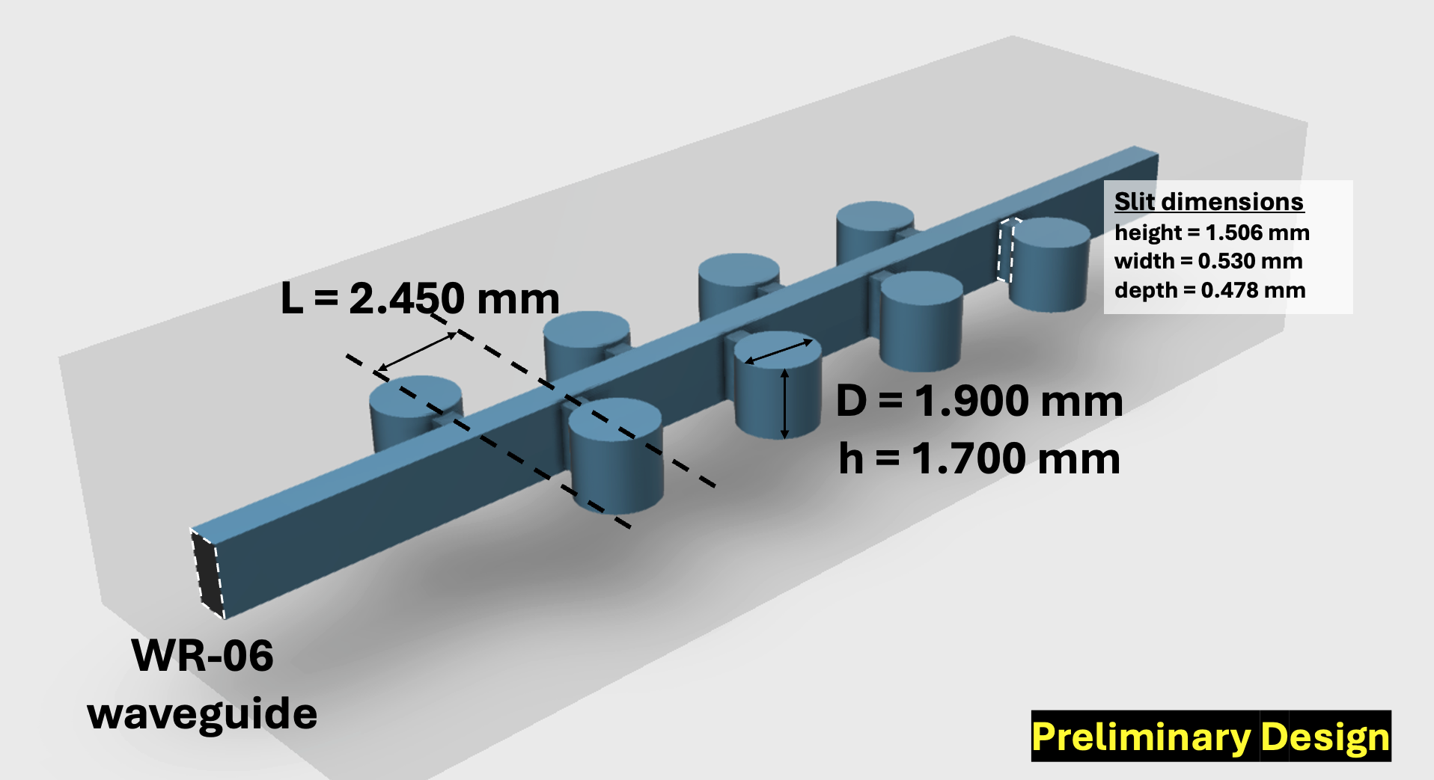
FIG. 3. Three-dimensional model of the preliminary eight-cavity ENOCH notch filter integrated into a WR-06 waveguide structure.
At this preliminary stage, the design is based on an ideal mathematical model for resonance analysis of a single cavity, which is then replicated to form the multi-cavity structure. A key element not yet fully integrated into the initial analytical model is the coupling slit between each resonant cavity and the rectangular waveguide. Based on prior design experience and post-fabrication measurements, we have identified that the slit geometry subtly influences ENOCH's critical parameters, including the notch center frequency, rejection depth, and 3 dB bandwidth.
While maintaining an aspect ratio (height‑to‑width) of less than 3 for the slit significantly reduces machining complexity, which is highly beneficial for controlling costs and improving production yield. Consequently, the slit dimensions were initially set as 530 µm (width), 1506 µm (height), 478 µm (depth). These dimensions provide efficient electromagnetic coupling. Although fabrication of such small waveguide features is challenging, high-precision microfabrication techniques such as Computer Numerical Control (CNC) milling can realize the proposed design with the required accuracy.
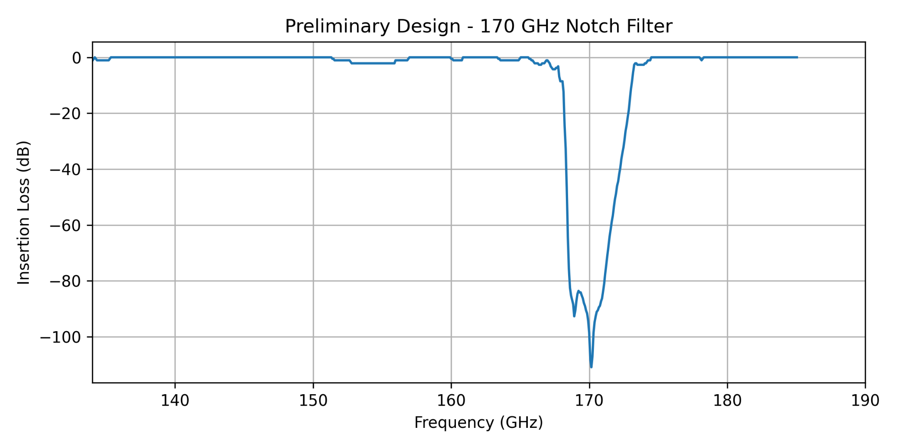
FIG. 4. Preliminary design simulation performance with notch frequency close to 170 GHz. The 3 dB bandwidth is around 6 GHz (167.21 to 173.20 GHz). The 60 dB bandwidth is approximately 3.17 GHz (168.43 to 171.60 GHz).
This initial geometry was modeled and analyzed using CST Microwave Studio (CST MWS) ²⁹, a specialized tool for 3D electromagnetic simulation of high-frequency devices. A broadband simulation from 135 GHz to 185 GHz was performed to analyze the transmission loss of the microwave signal, yielding the initial performance results shown in Fig. 4. The preliminary filter design demonstrates strong rejection performance with a center frequency close to 170 GHz and a minimum insertion loss exceeding 100 dB at the notch frequency. The extracted 3 dB bandwidth is approximately 6 GHz, while the 60 dB rejection bandwidth is about 3.2 GHz, indicating effective suppression of unwanted signals around the target frequency. Future design improvements should focus on reducing the notch bandwidth to achieve higher frequency selectivity, minimizing passband insertion loss, and improving out-of-band transmission flatness.
IV. OPTIMIZED DESIGN and POWER HANDLING ANALYSIS
Following the preliminary results presented in Section 3, which exhibited two undesirable notch frequencies due to inaccuracies in the initial cavity dimensions and inter-cavity spacing, a systematic optimization of ENOCH (Electromagnetic Notch Filters for Electron Cyclotron Heating) was performed. The primary optimization objectives were fourfold: first, to eliminate the dual-notch behavior and achieve a single, deep rejection notch at exactly 170 GHz; second, to maximize the rejection depth at the ECH interference frequency; third, to minimize insertion loss across the high priority 134–166 GHz diagnostic passband; and fourth, to maintain manufacturability within standard CNC machining tolerances.
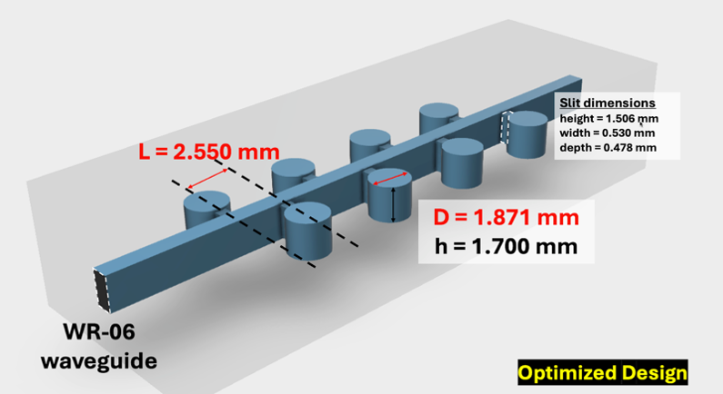
FIG. 5. Three-dimensional model of the optimized ENOCH notch filter showing the eight coupled resonant cavities integrated into a WR-06 waveguide structure.
Two geometrical parameters were identified as critical for achieving these objectives: the inter-cavity gap distance (L) and the cavity diameter (D). The gap distance was adjusted from 2.450 mm to 2.550 mm, while the cavity diameter was fine-tuned from 1.900 mm to 1.871 mm. All other structural parameters, including the cavity height (h = 1.700 mm) and the coupling slit dimensions (width = 0.530 mm, height = 1.506 mm, depth = 0.478 mm), were retained from the preliminary design, as they already satisfied the aspect ratio requirement of less than 3 for manufacturability. Table I summarizes the key structural parameters of ENOCH across the preliminary and optimized iterations.
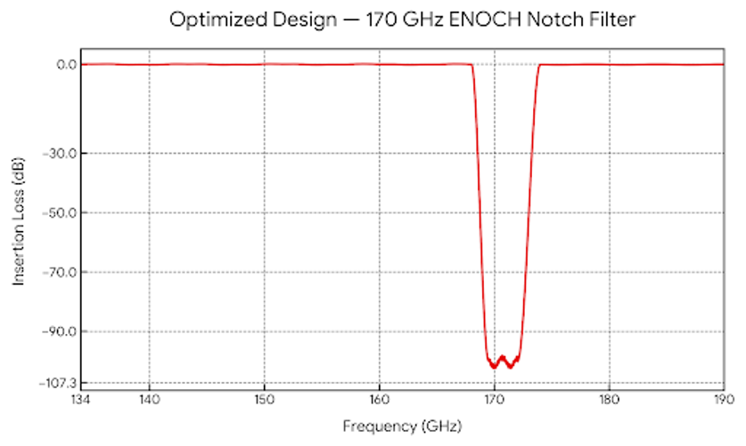
FIG. 6. Preliminary design simulation performance with notch band fully covers 170 GHz. The 3 dB bandwidth is around 6 GHz (168 to 173 GHz). The 60 dB bandwidth is approximately 3.15 GHz (168.90 to 172.05 GHz).
Concurrently, ENOCH maintains outstanding passband performance across the 134–166 GHz diagnostic window, with a maximum insertion loss of only 0.85 dB. This ensures a high signal-to-noise ratio for diagnostic measurements such as Microwave Reflectometry (MR), Electron Cyclotron Emission (ECE), Collective Thomson Scattering (CTS), and Doppler Backscattering (DBS). The iterative optimization delivered two key performance improvements: first, the elimination of the dual-notch frequencies in favor of a single, deep notch at 170 GHz with rejection exceeding 90 dB; and second, stabilization of the passband flatness across the 134–166 GHz window, with ripples restricted below 1.5 dB.
The broadband transmission characteristics of the optimized design were simulated using CST Microwave Studio, and the resulting 3D model of the eight-cavity ENOCH structure is shown in Fig. 5. The optimized design successfully meets all essential specifications for a 170 GHz notch filter. As shown in the full transmission spectrum (Fig. 6), this final iteration achieves a notch depth of 94.5 dB at 170 GHz, providing excellent suppression of the ECH interference signal before it can reach the sensitive downstream detectors. This represents a significant improvement over the preliminary design, which exhibited two distinct notch frequencies; the optimization successfully removed the dual-notch behavior while maintaining a deep rejection exceeding 90 dB.
TABLE I. Structural Parameters of ENOCH across Optimization Iterations.
Parameter | Description | Preliminary Design | Optimized Design
h (mm) | Cavity Height | 1.700 | 1.700
L (mm) | Inter-cavity Gap | 2.450 | 2.550
D (mm) | Cavity Diameter | 1.900 | 1.871
Slit_w (mm) | Slit Width | 0.530 | 0.530
Slit_h (mm) | Slit Height | 1.506 | 1.506
Slit_d (mm) | Slit_Depth | 0.478 | 0.478
Beyond electromagnetic performance, the optimized geometry is fully compatible with existing CNC machining capabilities. The chosen dimensions ensure manufacturability, high production yield, and effective cost control, thereby guaranteeing a secure supply chain for the component. Figure 5 presents the 3D model of the optimized eight-cavity ENOCH design, highlighting the precise arrangement of cavities and coupling slits that collectively enable the filter's superior rejection characteristics.
In plasma diagnostic systems, spurious gyrotron signals at 170 GHz can reach extrmely high-power levels, up to 20 MW in the burning plasma design. The inherently compact dimensions of high-frequency waveguides exacerbate this issue by limiting the available surface area for heat dissipation, making thermal management a critical concern for ENOCH. To evaluate the power handling capability of the designed filter and anticipate potential operational failure, a dedicated thermal analysis was performed across various input power levels. At the resonant frequency, the majority of the input power is confined within the cavities; however, a fraction is dissipated as heat due to conduction currents on the inner cavity walls, leading to a temperature increase. The resulting ohmic loss strongly depends on the material conductivity, making it a key factor in thermal performance.
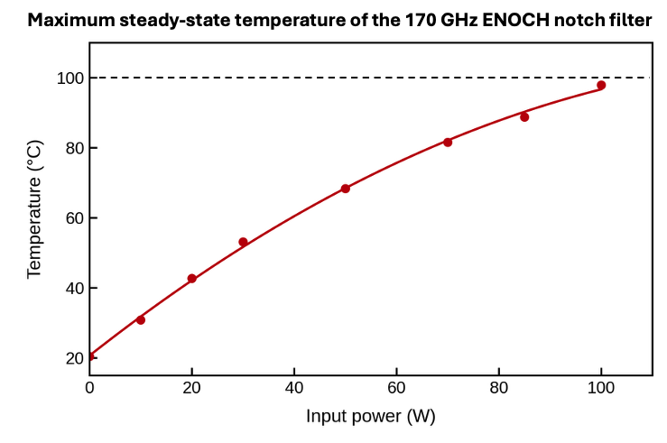
FIG. 7. Simulated maximum inner wall temperature of the ENOCH filter as a function of continuous RF input power under natural convection cooling. The red dots represent the Ansys Icepak simulation results, while the solid curve indicates the fitted thermal trend.
A multi-physics simulation coupling electromagnetic (EM) and steady-state thermal analyses was conducted using Ansys Icepak ³⁰. The EM simulation first computed the field distribution and subsequent surface power loss within the copper filter structure. This power loss data was then imported into the Ansys Icepak solver as a heat source to evaluate the steady-state temperature rise, assuming an ambient temperature of 20°C with convective air cooling. Although the gyrotron output can reach 20 MW, only a small fraction of reflected or stray power is expected to couple into the diagnostic front-end waveguide. Figure 7 shows the maximum inner wall temperature rise across a continuous RF power sweep from 0 to 100 W under air cooling only; the red dots represent the Ansys HFSS simulation results, while the smooth curve models the steady-state thermal trend toward the 100°C operational safety limit. As expected, the highest temperature is localized near the entrance of the first cavity, where the electromagnetic energy is most concentrated.
The analysis reveals that for the current uncooled design, the filter's inner wall temperature reaches 97.9°C under a continuous input power of 100 W, satisfying the primary <100°C constraint. However, if continuous input power scales beyond 100 W, temperatures exceed 100°C, risking voltage breakdown at the narrow coupling slots or causing performance-degrading thermal expansion. The relationship between input power (from 1 W to 100 W) and the resulting maximum inner wall temperature is quantified linearly in our multi-physics sweep, confirming the thermal stability trend. Therefore, for reliable operation at higher power levels, the implementation of additional heat sinking on the filter's outer surface is recommended to enhance cooling.
V. CONCLUSION and OUTLOOK
This paper has presented the design, optimization, and thermal analysis of ENOCH (Electromagnetic Notch Filters for Electron Cyclotron Heating), a novel 170 GHz waveguide-based notch filter engineered to protect sensitive microwave diagnostics from high-power ECH stray radiation in burning plasma devices. Implemented in a standard WR-06 waveguide with an eight-cavity resonant structure, the optimized ENOCH design achieves a rejection depth of 94.5 dB at the 170 GHz interference frequency while maintaining a low insertion loss of only 0.85 dB across the critical 134–166 GHz diagnostic passband. A multi-physics thermal analysis confirms that the uncooled filter withstands 100 W of continuous-wave input power with a maximum inner wall temperature of 97.9°C, satisfying the operational safety constraint of 100°C under natural convection cooling.
The chosen geometry, including an cavity gap of 2.550 mm, a cavity diameter of 1.871 mm, is fully compatible with standard CNC machining, ensuring manufacturability, high yield, and cost-effectiveness. The successful demonstration of ENOCH establishes a critical enabling technology for microwave diagnostics in ITER- and ARC-class tokamaks. Future work will focus on prototype fabrication and high-power experimental validation to transition the design from simulation to experimental implementation, with further extensions envisioned for even higher ECH power regimes exceeding 20 MW.
VI. ACKNOWLEDGMENTS
This work is supported by the US Department of Energy under US DoE grant DE-SC0026427 and by the FEAT Centre and STRIDE.
VII. DATA AVAILABILITY STATEMENT
The data that support the findings of this study are available from the corresponding author upon reasonable request.
VIII. REFERENCES
- A. A. Ovsyannikov and M. F. Zhukov, eds., Plasma Diagnostics (Cambridge Int. Science Publishing, 2000).
- Y. Chen, Rev. Sci. Instrum. 95, 093516 (2024).
- G. Yu et al., Nucl. Fusion 66 036024 (2026).
- X. Li et al., JINST 19, P06046 (2024).
- Y. Zhu et al., Rev. Sci. Instrum. 93, 113509 (2022).
- X. Li et al., Plasma Phys. Control. Fusion 67 055021 (2025).
- Y. Zhu et al., Rev. Sci. Instrum. 91, 093504 (2020).
- G. Yu et al., J. Plasma Phys. 90, 985900601 (2024).
- X. Yu et al., Plasma Sci. Technol. 25, 125601 (2023).
- G. Yu et al., Rev. Sci. Instrum. 95, 073505 (2024).
- R. M. Churchill et al., Phys. Plasmas 27, 062510 (2020).
- Z. Zhang et al., Fusion Eng. Des. 177, 113065 (2022).
- M. Hasegawa et al., J. Plasma Fusion Res. 80, 53 (2004).
- G. Yu et al., Rev. Sci. Instrum. 93, 103502 (2022).
- P. Sun et al., Plasma Phys. Control. Fusion 67, 085029 (2025).
- X. Li et al., Rev. Sci. Instrum. 95, 073519 (2024).
- Y. Li et al., Nucl. Fusion 66 016003 (2025).
- C. Luo et al., Plasma Sci. Technol. 28 015602 (2025).
- V. Furtula et al., Electron Cyclotron Emission And Electron Cyclotron Resonance Heating (Ec-16) (2011), pp. 228–233.
- S. Qiu et al., Rev. Sci. Instrum. 95, 023503 (2024).
- L. Himes et al., JINST 19, P10024 (2024).
- C. Luo et al., Fusion Eng. Des. 214, 114925 (2025).
- Z. Yang et al., JINST 13, P07031 (2018).
- C. W. Domier et al., JINST 17, C02010 (2022).
- X. Li et al., Plasma Phys. Control. Fusion 67 115009 (2025).
- X. Yu et al., Rev. Sci. Instrum. 97, 053501 (2026).
- X. Li et al., Fusion Sci. Technol. (2025): 1-9.
- J. Damba et al., Rev. Sci. Instrum. 93, 103505 (2022).
- Studio, CST Microwave. "CST Microwave studio." 2008.
- S. J. Yaseen et al., Int. J. Thermofluids 23, 100759 (2024).

